

UNDERGRADUATE PROJECT REPORT

|  |  |
| --- | --- |
| **Project Title:** | **Multi-Class Diabetic Retinopathy Classification using Residual Networks** |
| **Surname:** | **Li** |
| **First Name:** | **Tong** |
| **Student Number:** | **202118010414** |
| **Supervisor Name:** | **Dr Happy Nkanta Monday** |
| **Module Code:** | **CHC 6096** |
| **Module Name:** | **Project** |
| **Date Submitted:** | **May 6, 2025** |

# **Declaration**

**Student Conduct Regulations**:

Please ensure you are familiar with the regulations in relation to Academic Integrity. The University takes this issue very seriously and students have been expelled or had their degrees withheld for cheating in assessment. It is important that students having difficulties with their work should seek help from their tutors rather than be tempted to use unfair means to gain marks. Students should not risk losing their degree and undermining all the work they have done towards it. You are expected to have familiarised yourself with these regulations.

<https://www.brookes.ac.uk/regulations/current/appeals-complaints-and-conduct/c1-1/>

Guidance on the correct use of references can be found on www.brookes.ac.uk/services/library, and also in a handout in the Library.

The full regulations may be accessed online at <https://www.brookes.ac.uk/students/sirt/student-conduct/>

If you do not understand what any of these terms mean, you should ask your Project Supervisor to clarify them for you.

**I declare that I have read and understood Regulations C1.1.4 of the Regulations governing Academic Misconduct, and that the work I submit is fully in accordance with them**.

Signature …………………………………………. Date …………………………………………

REGULATIONS GOVERNING THE DEPOSIT AND USE OF OXFORD BROOKES UNIVERSITY MODULAR PROGRAMME PROJECTS AND DISSERTATIONS

Copies of projects/dissertations, submitted in fulfilment of Modular Programme requirements and achieving marks of 60% or above, shall normally be kept by the Oxford Brookes University Library.

**I agree that this dissertation may be available for reading and photocopying in accordance with the Regulations governing the use of the Oxford Brookes University Library.**

Signature …………………………………………. Date ………………………………………….

# **Acknowledgment**

Here, students are given the opportunity to thank those who have provided you with assistance and support.

# **Table of Contents**

**Declaration** i

**Acknowledgment** ii

**Table of Contents** iii

**Abstract** v

**Abbreviations** vi

**Glossary** vii

**Chapter 1 Introduction** 1

**1.1.1** **Convolutional Neural Network (CNN) Overview** 2

**1.1.2** **Max Pooling** 3

**1.1.3** **Residual Networks** 3

**1.1.4** **Learnable Wavelet** 4

**1.1.5** **Squeeze-and-Excitation Block** 5

**1.1.6** **Multi-head attention mechanism** 5

**1.1.7** **Softmax** 6

**1.1.8** **L2 regularization** 7

**Chapter 2 Background Review** 10

**Chapter 3 Methodology** 13

**3.1** **Approach** 13

**3.2** 13

**3.3** **Testing and Evaluation Plan** 13

**3.3.1** **Data testing** 13

**3.3.2** **Model Performance Evaluation Criterias** 13

**3.4** 14

**3.5** **Technology** 14

**3.6** **Project Version Management** 15

**Chapter 4 Implementation and Results** 17

**Chapter 5 Professional Issues** 18

**5.1** **Project Management** 18

**5.1.1** **Activities** 18

**5.1.2** **Schedule** 19

**5.1.3** **Project Data Management** 19

**5.1.4** **Project Deliverables** 20

**5.2** **Risk Analysis** 20

**5.3** **Professional Issues** 22

**Chapter 6 Conclusion** 24

**References** 25

**Appendices** 27

# **Abstract**

Up to 250 words, concise outline of background, aims, results, and achievements.

***Keywords: ResNet, Custom Loss Function, Class Imbalance, Image Classification***

# **Abbreviations**

This section should have the definition of any abbreviations used in the report

# **Glossary**

This section should have the definition of all the keywords you stated in the “Abstract” section. You can also define other relevant keywords. Particularly, if your final project report includes rare, unfamiliar, specialized, or made-up words or terms, the glossary serves as a dictionary for the reader to reference throughout their reading of the project report. (Note: this section should only contain definitions for specific terms in the project report. It does NOT function as an ordinary dictionary. Hence, common words related to the Computer Science and Software Engineering disciplines should NOT be included in this list.)

# **Introduction**

* 1. **Background**

Diabetic retinopathy (DR), a complication of diabetes, harms the retinal blood vessels and can lead to vision impairment or even blindness, making early detection crucial [1]. It is one of the most significant organ manifestations of diabetes; globally, about one-third of diabetic patients show clinical signs of DR, among which 5–10% are in severe, vision-threatening forms [2].

In the detection of diabetic retinopathy, deep convolutional neural networks (Deep CNNs), combined with optimization algorithms, have become key tools for improving classification accuracy [3]. Among these, Residual Neural Networks (ResNet) stand out as deep learning models particularly suited for handling complex image recognition tasks, such as DR classification [4]. The effectiveness of ResNet lies in its ability to efficiently learn from large datasets while addressing the gradient vanishing issue, making it especially valuable for complex image analysis [5].

Recent studies have introduced variants of ResNet, such as CS-ResNet-101 and revised ResNet-50, to tackle the challenges of DR classification. These models incorporate enhanced pooling functions and attention mechanisms to improve their ability to extract relevant features from retinal images, thereby significantly boosting classification accuracy [6], [7]. Moreover, the integration of transfer learning with pre-trained networks has further enhanced these models, enabling them to achieve excellent generalization across diverse datasets [8].

In addition, Transformer models based on multi-head attention mechanisms have demonstrated exceptional performance in recent computer vision tasks and have been successfully applied to the automatic grading of DR severity [9]. Furthermore, explainable artificial intelligence (XAI) has emerged as an essential research area to address the interpretability challenges inherent in complex machine learning models [10]. Similarly, incorporating wavelet-based feature decomposition has gained attention for its ability to enhance spatial efficiency and highlight structural information in visual representations [11].

Nevertheless, classification algorithms in image recognition tasks often face challenges posed by class imbalance in training datasets. This imbalance can significantly reduce the accuracy of predictions for minority classes [12]. For instance, in the Kaggle dataset, the number of healthy fundus images far exceeds those with DR, leading to an imbalance that directly complicates the task of DR classification [7]. Common loss functions do not adapt well to this disparity, which can lead to imbalanced learning behavior and reduced attention to less frequent classes.

To address this issue, this project aims to develop a deep learning model that leverages ResNet’s robust feature extraction capabilities while incorporating a user-defined loss function to mitigate class imbalance commonly found in medical datasets. This approach is expected to improve the accuracy and specificity of DR classification, facilitating early detection and treatment of this vision-threatening disease.

### **Convolutional Neural Network (CNN) Overview**

A Convolutional Neural Network (CNN) is a specialized deep learning model primarily used for processing grid-like data, such as images. CNNs are designed to automatically and adaptively learn spatial hierarchies of features by applying convolutional filters across the input data. These networks consist of layers such as convolutional layers, pooling layers, and fully connected layers. The convolutional layers extract low-level features like edges, while pooling layers reduce the spatial dimensions to retain only the most important information. Finally, fully connected layers integrate these learned features to make predictions, such as classifying objects or detecting specific patterns. Figure 1 illustrates a basic architecture of a CNN, where the input image passes through multiple convolutional and pooling layers, followed by fully connected layers to produce the final output. CNNs are particularly effective in image classification, object detection, and segmentation tasks due to their ability to handle large datasets efficiently and capture complex, spatially invariant features [13].

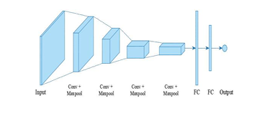

**Figure 1:** A basic architecture of a convolutional neural[13]

### **Max Pooling**

Max pooling is a widely used technique in Convolutional Neural Networks (CNNs) that reduces the spatial dimensions of feature maps while retaining the most important information. The max pooling operation selects the maximum value within a sliding window, often of size 2×2, to downsample the feature map. This operation helps improve computational efficiency and enhances the network's robustness by focusing on the most prominent features of the data. In CNNs, pooling layers are placed between convolutional layers to reduce the dimensionality and introduce invariance to small translations of the input. Max pooling has become the most popular pooling method because it is particularly effective in preserving essential features while compressing the image representation. However, a key challenge with max pooling is the potential loss of edge features, which may affect the model’s ability to detect certain fine-grained details. Figure 2 illustrates examples of max pooling and average pooling operations, demonstrating how each method reduces the spatial dimensions of the input feature map by selecting either the maximum or average value within the pooling window [14].

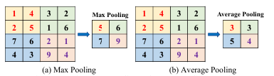

**Figure 2:** Examples of max pooling and average pooling operations[14]

### **Residual Networks**

Residual Networks (ResNet) are a deep learning architecture designed to address the challenges of training very deep neural networks. The core idea behind ResNet is the introduction of residual connections, which allow the output from one layer to bypass one or more layers and be added to the next. This helps mitigate the vanishing gradient problem, making it easier to train deeper networks without the loss of important information. The basic building block of ResNet is the residual unit, which consists of convolutional layers followed by batch normalization and activation functions like ReLU. These residual units are stacked together to form deeper networks, allowing the model to learn more complex features without degrading performance. ResNet's ability to build very deep networks while maintaining efficient training has made it highly effective in a variety of tasks, as the residual connections enable the model to focus on learning only the residual information that is difficult to capture in shallow networks. Figure 1 illustrates the structure of a residual unit, where a residual connection bypasses the convolutional and activation layers to add the input directly to the output [15].

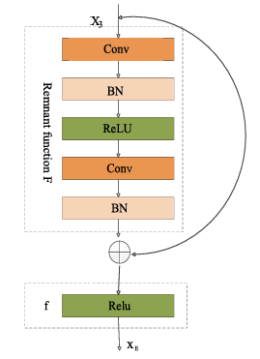

**Figure 3:** Residual unit [15]

### **Learnable Wavelet**

Learnable Wavelet transforms leverage wavelet-based features for deep learning models, offering an alternative to traditional convolutional operations. In these models, the wavelet filters are learned during training, enabling the network to adaptively learn more complex features from the data. Unlike fixed wavelet transforms, learnable wavelets can be tuned to better capture the specific characteristics of the input data. This flexibility provides an advantage in applications where conventional convolutional methods might not capture sufficient detail, such as in highly variable or multi-scale data sets. The approach enhances the model's ability to process both spatial and frequency domain features by applying wavelet transforms that adapt as the network learns, improving performance on tasks like image denoising, segmentation, and classification [11]

### **Squeeze-and-Excitation Block**

The Squeeze-and-Excitation (SE) block is a powerful technique introduced to enhance the representational capabilities of Convolutional Neural Networks (CNNs). The SE block focuses on selectively amplifying or suppressing feature responses across different channels. This is achieved by performing a squeeze operation, which applies global average pooling over all feature maps to minimize spatial size into a single value, followed by excitation, where the feature map is scaled using per-channel weight modulation. The operation involves two fully connected layers: the first layer captures channel-wise relationships using ReLU activation, and the second layer uses a sigmoid activation to generate scaling factors. These scaling factors are then used to adjust the feature maps, emphasizing more important channels while reducing less significant ones. This approach improves the network's ability to prioritize relevant features, thus enhancing performance across various applications such as image forgery detection. Figure 4 shows the structure of the Squeeze-and-Excitation block, where the feature map is first squeezed using global average pooling, followed by excitation, which generates scaling factors to adjust the feature map accordingly [16].

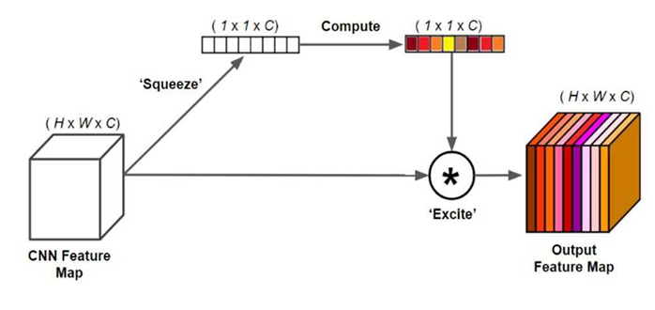

**Figure 4:** Squeeze-and-Excitation Block [16]

### **Multi-head attention mechanism**

The multi-head attention mechanism is a crucial component of Transformer models, enabling the model to focus on different parts of the input sequence simultaneously. The mechanism works by projecting the input queries (Q), keys (K), and values (V) into different subspaces through linear transformations. Multiple attention heads independently perform scaled dot-product attention, capturing various aspects of the input sequence. The results of each attention head are then concatenated and passed through a final linear transformation to produce the output. This mechanism allows the model to learn complex relationships within the data by attending to multiple parts of the input sequence, enhancing the model's ability to capture dependencies at different levels of abstraction. As shown in Figure 1, the multi-head attention mechanism consists of parallel attention heads, each focusing on different parts of the input, which are then combined to create the final output [17].

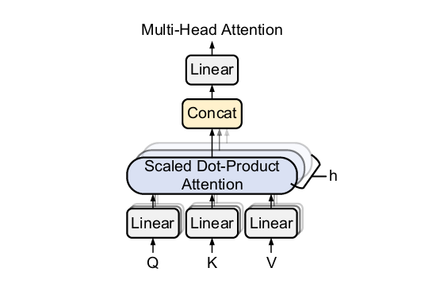

**Figure 5:** Multi-Head Attention Architecture [17]

### **Softmax**

The Softmax function is commonly used in machine learning models, particularly for classification tasks, to convert the raw model outputs (logits) into probabilities. It applies the exponential function to each element of the input vector, and then normalizes the result by dividing by the sum of all the exponentials. The formula for the Softmax function is:

|  |  |
| --- | --- |
| $$Softmax\left(z_{i}\right)=\frac{e^{z_{i}}}{\sum_{j}{e^{z_{j}}}}$$ | (1) |

Where:

* $z_{i}$ is the raw output (logit) for class i,
* $e^{z_{i}}$ is the exponential function applied to the logit,
* The denominator $\sum_{j}{e^{z_{j}}}$ is the sum of the exponentials of all logits, ensuring that the output is a probability distribution.

The Softmax function ensures that the outputs are in the range (0, 1) and sum to 1, making it ideal for multi-class classification tasks.

### **L2 regularization**

L2 regularization, also known as Ridge Regularization, is a technique used to prevent overfitting in machine learning models by adding a penalty term to the loss function. This penalty is based on the squared values of the model’s weights. The idea behind L2 regularization is to encourage the model to keep its weights small, effectively reducing the complexity of the model and improving its ability to generalize. By minimizing both the original loss and the penalty term, L2 regularization helps balance the trade-off between fitting the training data and avoiding overfitting.

* 1. **Aim**

Automated DR classification using deep learning holds great potential for early diagnosis, but challenges such as class imbalance and subtle inter-grade differences remain significant obstacles. To address these issues, the aim of this project is to develop a deep learning model based on a residual network architecture with a customized loss function to address the class imbalance problem and ensure accurate classification of all grades of diabetic retinopathy.

* 1. **Objectives**
* **Data Collection and Preparation:** This project utilizes the APTOS 2019 Blindness Detection dataset from Kaggle, which contains labeled retinal fundus images categorized into five stages of diabetic retinopathy (0–4). The dataset is split into 80% for training,10% for verification and 10% for testing. Preprocessing includes center cropping, resizing all images to 224×224, and normalization to scale pixel values to [0, 1]. In addition, data augmentation techniques such as horizontal flipping and random rotation are applied to enhance model generalization and address class imbalance.
* **Model Development:** Design a ResNet-based model specifically optimized for diabetic retinopathy classification. Implement a custom loss function to address class imbalance, improving the model's accuracy across all severity levels.
* **Training and Optimization:** Train the model on the prepared APTOS 2019 Blindness Detection dataset using optimized hyperparameters, including learning rate, batch size, and dropout rate. The training process is enhanced with callback techniques such as EarlyStopping to prevent overfitting, ReduceLROnPlateau to dynamically adjust the learning rate when validation performance plateaus, and ModelCheckpoint to save the best-performing model based on validation loss. These strategies collectively improve training efficiency and model generalization.
* **Model Evaluation and Validation:** Evaluate the model's performance using comprehensive metrics such as accuracy, precision, recall, F1-score, and AUC, ensuring its reliability and generalization across the diverse image samples in the dataset. Additionally, apply Explainable AI (XAI) techniques including SHAP, Grad-CAM, and LIME to interpret the model’s predictions, visualize decision regions, and provide transparency for clinical relevance and trustworthiness.

The final model will be deployed through a web-based interface, allowing users to upload retinal fundus images for automated classification of diabetic retinopathy severity.

* 1. **Project Overview** 
     1. **Scope**

Severe class imbalance is a persistent issue in diabetic retinopathy (DR) image classification, where early stages are overrepresented while advanced stages are relatively rare. This imbalance skews model learning, causing overfitting to dominant classes and significantly reducing the sensitivity to minority classes [18].Conventional loss functions, such as cross-entropy, tend to amplify this issue by assuming uniform class distribution, resulting in biased gradient updates and unstable optimization. This leads to high overall accuracy but poor recall on critical underrepresented stages, which undermines clinical reliability.

To address this, it is essential to incorporate a loss function that reflects the true class distribution. This project adopts Balanced Softmax, which adjusts the loss computation based on class frequency, thereby aligning the learning objective with the real-world data imbalance [19]. This approach enables more balanced gradient updates and improves learning for rare classes without altering the dataset itself. By integrating Balanced Softmax with a ResNet-based model, supported by image preprocessing, augmentation, and performance-driven training strategies, thereby enhancing the overall reliability of the model in real-world clinical scenarios.

This project holds the following significance and potential contributions:

* Improved Diagnostic Accuracy for Diabetic Retinopathy
* Balanced Classification Performance Across DR Severity Stages
* Reduced Rate of Missed Diagnoses and False Positives
* Early Detection and Timely Intervention
* Optimized Use and Allocation of Ophthalmic Healthcare Resources
* Enhanced Efficiency in Clinical Diagnosis Processes
* Lowered Healthcare Costs through Automated Screening
* Increased Patient Accessibility to Reliable DR Screening
* Promotion of Public Awareness Regarding Diabetic Eye Complications
* Support for Clinical Decision-Making with AI-driven Insights
  + 1. **Audience**

The findings of this project, which apply deep learning techniques to diabetic retinopathy classification, will provide numerous benefits to stakeholders.

**Healthcare Professionals:** Ophthalmologists and general practitioners will benefit from the enhanced accuracy of diabetic retinopathy classification provided by the developed model. The tool can aid in early detection, thus improving treatment outcomes and patient care.

**Medical Institutions:** Hospitals and clinics will experience improved diagnostic workflows and reduced rates of misdiagnosis.

**Diabetic Patients:** Patients diagnosed with diabetes will gain from more timely and accurate diagnoses, allowing for earlier intervention and treatment.

**Researchers:** Researchers in the fields of machine learning and medical imaging will have access to a valuable tool for analyzing medical images, facilitating advancements in the understanding and treatment of diabetic retinopathy.

# **Background Review**

Diabetic Retinopathy (DR) is a severe diabetes-related eye disease characterized by five distinct stages. However, significant class imbalance exists regarding the number of images available for each stage. Below are related studies addressing DR classification and strategies designed to mitigate class imbalance.

Romero-Oraá et al. [20] proposed an attention-based deep learning framework for DR grading, using dual-path attention to separately highlight bright and red lesions on EyePACS data. The model achieved 83.7% accuracy and a QWK of 0.78, showing strong performance and interpretability. However, its reliance on image decomposition and low-resolution attention maps may limit fine-grained lesion localization and increase computational cost.

Suo et al. [6] proposed a CS-ResNet-101 model for DR classification by integrating channel attention (CAM) and spatial attention (FCSAM) into ResNet-101, along with an adaptive image enhancement method and an improved weighted cross-entropy loss to handle class imbalance. The model achieved 98.1% accuracy on the EyePACS dataset and 97.15% accuracy on APTOS 2019, demonstrating strong generalization. However, the model requires pretraining on a large-scale dataset (EyePACS) to perform well on APTOS, indicating potential dependency on cross-dataset knowledge transfer for achieving optimal results.

Yang et al. [21] proposed a Transformer-based multiple instance learning (TMIL) model that classifies high-resolution retinal images by aggregating patch-level features through a Global Instance Computing Block. It achieved 85.6% accuracy, 95.6% AUC, and a 91.5% Kappa score on APTOS, while reducing inference time over standard ViTs. However, the model lacks explicit handling of class imbalance, and its effectiveness on minority DR stages remains limited.

**Al-ahmadi et al.** [22] compared several CNN architectures, including DenseNet121 and ResNet-101, for five-class DR classification on a combined Kaggle dataset, with DenseNet121 achieving **87% accuracy.** While the results are promising, the approach relies on pretrained weights and does not explicitly address class imbalance. Additionally, the absence of detailed implementation steps may pose challenges for replication or practical adaptation.

**Alavee et al.** [23] developed a custom CNN model for binary and multi-class DR classification, achieving **95.27% accuracy** on the APTOS 2019 dataset. The model leveraged data augmentation to handle class imbalance and incorporated **Grad-CAM** for visual interpretability. However, the approach primarily relies on oversampling techniques, which may introduce overfitting risks, and the explainability is limited to local visual cues without deeper model-level interpretation.

**Baskar et al.** [24] used transfer learning with AlexNet and DenseNet-169 for five-class DR classification on APTOS2019 and DRC datasets. Using SMOTE and augmentation, DenseNet-169 achieved **82.7% accuracy** and an **F1-score of 0.69** for the PDR stage. However, classification performance on mild and moderate stages remained limited, especially under imbalanced conditions.

**Ganesh Kumar et al.** [25]applied InceptionV3 and ResNet50 with transfer learning and augmentation for five-class DR classification. InceptionV3 achieved **94.1% accuracy** and ResNet50 **93.3%**, both with an **F1-score of 0.92**. Grad-CAM was used for interpretability. However, the models rely on standard architectures and oversampling, which may limit adaptability to more complex settings.

|  |  |  |  |
| --- | --- | --- | --- |
| **Author** | **Datasets** | **Methods** | **Results** |
| Romero-Oraá et al. [20] | EyePACS | Dual-path attention (bright/red lesions), focal loss | 83.7% accuracy, QWK 0.78 |
| Suo et al. [6] | EyePACS, APTOS 2019 | CS-ResNet-101 + CAM/FCSAM + weighted loss | 98.1% (EyePACS), 97.15% (APTOS); strong generalization |
| Yang et al. [21] | APTOS 2019 | Transformer + MIL + Global Instance Block | 85.6% acc, 95.6% AUC, Kappa 91.5 |
| Al-ahmadi et al. [22] | Combined Kaggle DR dataset | DenseNet121, ResNet101 + transfer learning | DenseNet121: 87% accuracy |
| Alavee et al. [23] | APTOS 2019 | Custom CNN + augmentation + Grad-CAM | 95.27% accuracy; strong binary and multi-class performance |
| Baskar et al.[24] | APTOS2019, DRC | DenseNet-169 + SMOTE oversampling | 82.7% acc, F1 0.69 (PDR class); limited on mild/moderate |
| Ganesh Kumar et al.[25] | Kaggle DR dataset | InceptionV3, ResNet50 + transfer learning + Grad-CAM | InceptionV3: 94.1% acc; ResNet50: 93.3%; both F1-score 0.92 |

Table 1: Summary of Related Works

# **Methodology**

## **Approach**

In this project, a deep convolutional neural network (CNN) image classification model based on the ResNet architecture is proposed, aiming to optimize classification performance by integrating several advanced techniques. The model is built upon the classic ResNet network architecture, inheriting its residual connections design to prevent the vanishing gradient problem in deep networks and maintain efficient learning capabilities in deeper network structures.

On this basis, a wavelet transform layer is introduced to extract multi-scale features through learnable wavelet decomposition, thereby enhancing the model's ability to perceive different frequency information. In addition, the model incorporates a Squeeze-and-Excitation (SE) block, which adaptively adjusts channel weights to further improve feature extraction capabilities.

To enhance the model's nonlinear feature representation, multi-head attention (MHA) and feed-forward networks (FFN) are added to the network. These mechanisms effectively capture complex relationships among input features, thereby improving model performance. Finally, dropout techniques are introduced during training to reduce overfitting and improve the model's generalization ability.

Overall, the model combines the ResNet architecture with various advanced techniques to enhance feature extraction, boost model expressiveness, and improve classification accuracy, demonstrating strong performance in handling complex image classification tasks.

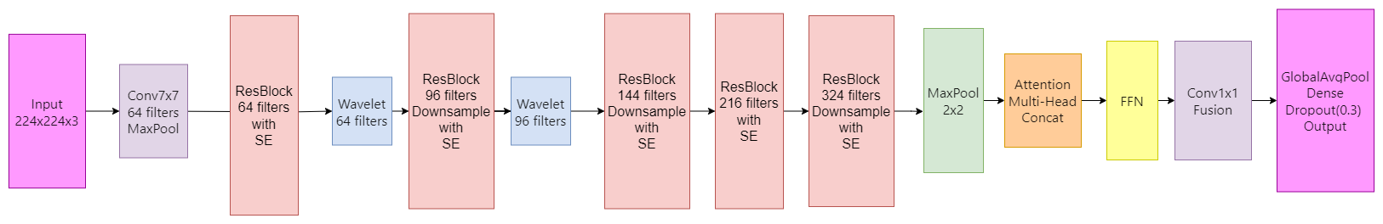

Figure 6: Multi-Scale Attention Residual Network

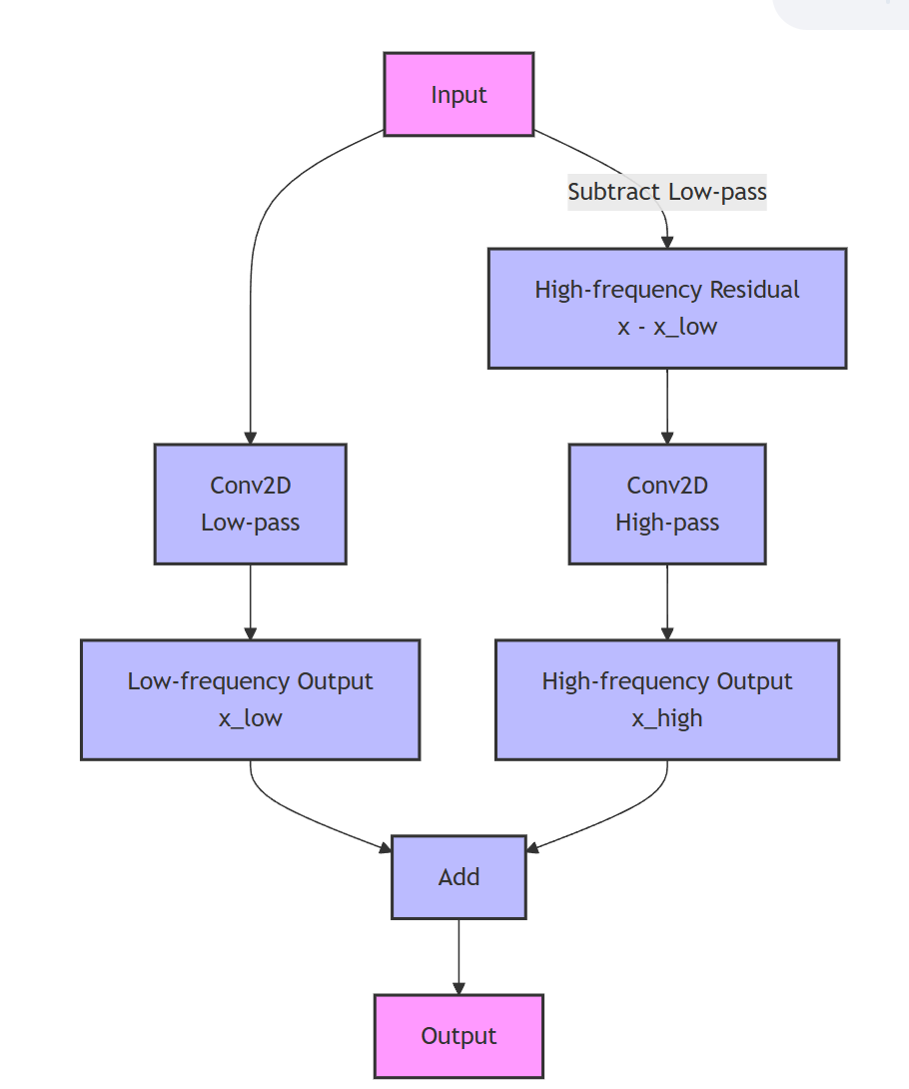

Figure 7: Learnable Wavelet Transform Layer



Figure 8: Squeeze-and-Excitation Block

The design of ResNet is based on the concept of residual learning, allowing information to be transmitted directly through shortcut connections in the network. This structure enables the network to maintain depth while addressing the vanishing gradient problem, thereby enhancing the learning of complex features [15].

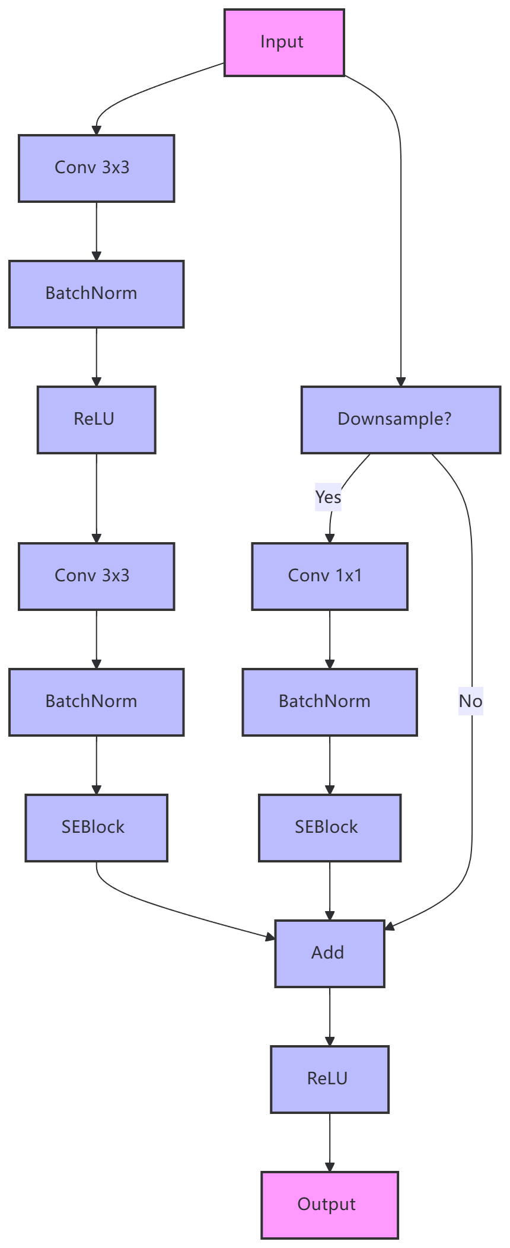

Figure 9: Residual SE Block



Figure 10: Multi Head Attention with Residual



Figure 11: Feed-Forward Network

### **Loss Function**

The Balanced Softmax Loss achieves class balance by adjusting logits with the following formula:

|  |  |
| --- | --- |
| $$adjusted_logits=logits+\log\left(class_counts\right)$$ | (1) |

Where:

* $logits$ represents the raw output from the model for each class.
* $\log\left(class_counts\right)$ represents the logarithm of the counts of each class, used to adjust logits to reflect class imbalance.

Thus, the adjusted loss function can be expressed as:

|  |  |
| --- | --- |
| $$L= -\sum_{i=1}^{N}{\sum_{j=1}^{K}{y_{ij}\log\left({\hat{y}}_{ij}+\log\left(class_counts\left[j\right]\right)\right)}}$$ | (2) |

Where:

* $N$ is the number of samples in the batch.
* $K$ is the total number of classes.
* $y_{ij}$ is the true label in one-hot encoding for the $i$-th sample and $j$-th class.
* ${\hat{y}}_{ij}$ is the predicted probability for the $i$-th sample and $j$-th class after applying the softmax function with adjusted logits.
* $\log\left(class_counts\left[j\right]\right)$ is the logarithm of the count of the $j$-th class, further enhancing the focus on minority classes.

${\hat{y}}_{ij}$ represents the softmax output after adjustment, calculated as follows:

|  |  |
| --- | --- |
| $${\hat{y}}_{ij}= \frac{e^{{adjusted_logits}_{j}}}{\sum_{k=1}^{K}{e^{{adjusted_logits}_{k}}}}$$ | (3) |

Where:

* $e^{{adjusted_logits}_{j}}$ is the exponential function applied to the adjusted logit.
* The denominator $\sum_{k=1}^{K}{e^{{adjusted_logits}_{k}}}$ is the sum of the exponentials of all adjusted logits, ensuring that the output is a probability distribution.

By employing the Balanced Softmax Loss function, we effectively mitigate the problem of class imbalance and improve the model's predictive performance on minority classes.

## 

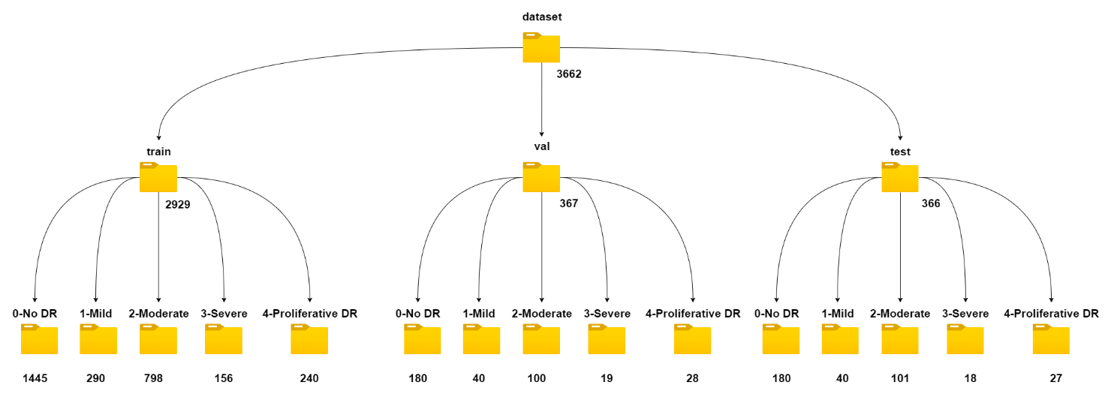

Figure 12: Dataset Structure

Figure 13: Number of images within APTOS 2019 Blindness Detection (public)

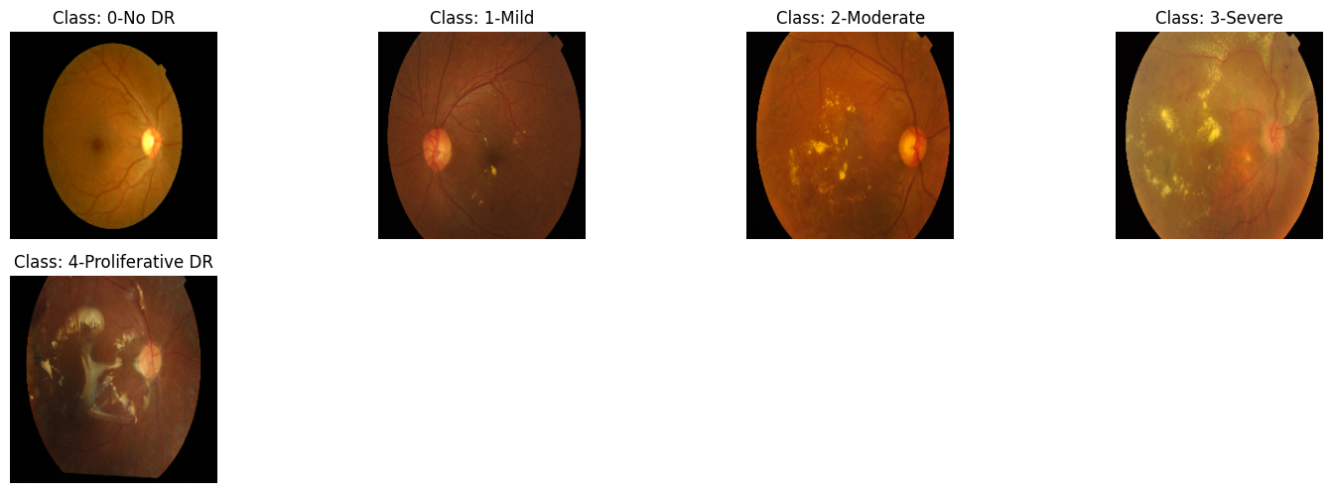

Figure 14: Different Classes of Diabetic Retinopathy.

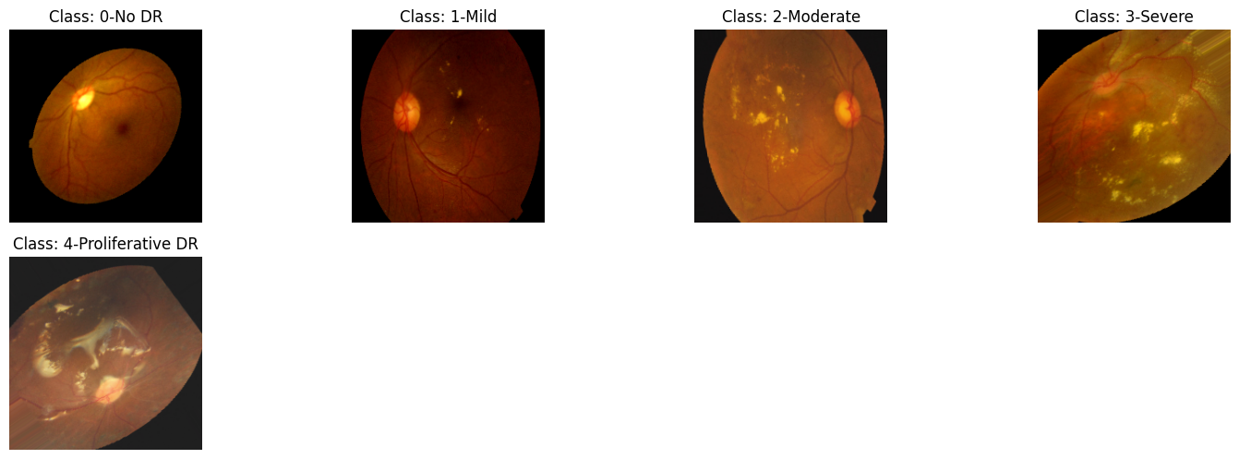

Figure 15: Preprocessed and Augmented Diabetic Retinopathy Classes

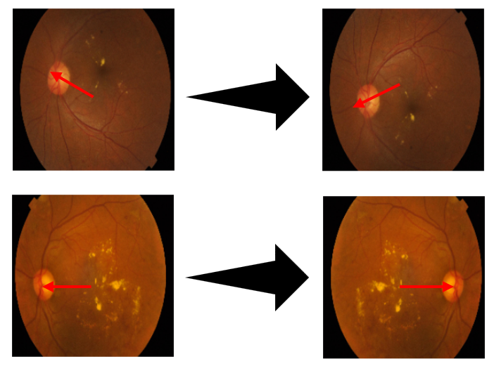

Figure 16: Flipped Fundus Image

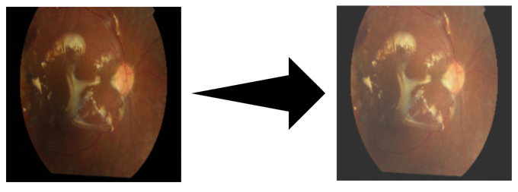

Figure 17: Channel Shift Visualization

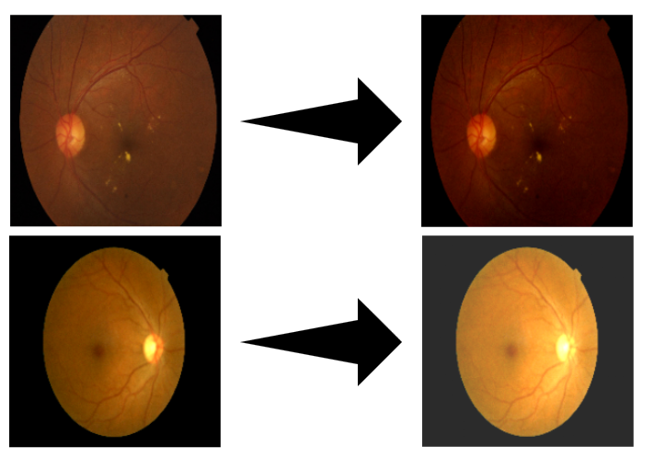

Figure 18: Brightness-Adjusted Image

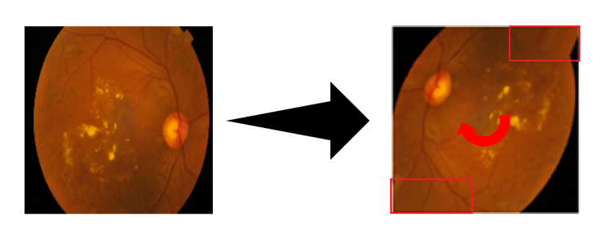

Figure 19: Rotated Image

## **Testing and Evaluation Plan**

### **Data testing**

**Dataset Partitioning:** The dataset was partitioned into three subsets: training (80%), validation (10%), and testing (10%). The split ensures a balanced distribution of data for model training, validation, and testing.

* **Partitioning Process**: The images were randomly distributed across the subsets, with each class proportionally represented in all subsets.
* **Verification**: The number of images in each partition was checked to confirm the split adhered to the intended 80:10:10 ratio.

**File Integrity Testing:** To ensure data accessibility and correctness, file integrity checks were performed.

* **File Count Verification**: After partitioning, the number of images in each set was cross-checked with the expected count for each subset.
* **Load Check**: A sample of images from each subset was checked to verify they loaded without errors or corruption.

**Data Label Testing:** Labeling accuracy is essential for correct model training and evaluation.

* **Label Consistency**: The images were verified to ensure they were placed in the correct subdirectories corresponding to their respective class labels. This was cross-checked with the class labels in the CSV or annotation files.

**Data Preprocessing:** The preprocessing pipeline included resizing images, normalizing pixel values, and applying augmentation to the training set.

* **Resize and Normalize**: All images were resized to 224x224 pixels, and pixel values were normalized to a range of [0, 1] for model compatibility.
* **Data Augmentation**: For the training set, augmentation techniques such as rotation, horizontal flip, and brightness adjustments were applied. A subset of augmented images was visually inspected to ensure key features were preserved.

**Comprehensive Pipeline Testing:** The entire data processing pipeline was tested for smooth operation and efficiency.

* **Data Loading**: The data loading process for training, validation, and testing was verified to ensure smooth and correct data flow into the model.
* **System Resource Monitoring**: Resource usage, including memory and processing time, was monitored during training, validation, and testing to assess the efficiency of the pipeline.

### **Model Performance Evaluation Criterias**

To comprehensively assess the model's performance, this study employs a series of common evaluation metrics. Specifically, the following assessment methods are used.

**1. Accuracy**

|  |  |
| --- | --- |
| $$Accuracy= \frac{\sum_{i=1}^{N}{\left({TP}_{i}+{TN}_{i}\right)}}{\sum_{i=1}^{N}{\left({TP}_{i}+{TN}_{i}+{FP}_{i}+{FN}_{i}\right)}}$$ | (9) |

This represents the proportion of correct predictions (TP+TN) for all classes over all samples.

|  |  |
| --- | --- |
| **2.** **Specificity** |  |
| $${Specificity}_{i}= \frac{{TN}_{i}}{{TN}_{i}+{FP}_{i}}$$ | (10) |

This is the specificity for each category, which indicates the proportion of samples that are actually negative that the model successfully predicts as negative.

|  |
| --- |
| **3. Recall/Sensitivity** |
| $${Recall}_{i}= \frac{{TP}_{i}}{{TP}_{i}+{FN}_{i}}$$ | (11) |
|  |  |

This is the recall rate for each category, which indicates the proportion of samples that are actually positive that the model successfully predicts as positive.

**4. Precision**

|  |  |
| --- | --- |
| $${Precision}_{i}= \frac{{TP}_{i}}{{TP}_{i}+{FP}_{i}}$$ | (12) |

This is the precision of each category, which indicates the proportion of positive samples predicted by the model to be of that category that are actually positive.

**5. F1 Score**

|  |  |
| --- | --- |
| $${F_{1} Score}_{i}= \frac{2{TP}_{i}}{2{TP}_{i}+{FP}_{i}+{FN}_{i}}$$ | (13) |

The F1 score is the harmonic mean of precision and recall, which is suitable for comprehensive consideration of precision and recall.

**6. Confusion Matrix**

The confusion matrix displays the model's classification results for different categories, covering TP, FP, TN, and FN. It reveals each category's classification effect and highlights easily confused ones.

**7. ROC-AUC Curve**

The ROC curve presents the model's performance across different decision thresholds. The AUC, representing the area under the curve, offers a comprehensive metric; the closer it is to 1, the better the model classifies. AUC calculation doesn't hinge on a specific threshold but assesses all possible ones.

**8. Precision-Recall Curve**

The precision-recall curve shows the changes in precision and recall under different decision thresholds.

**9. Macro Average and Micro Average Metrics**

In this study, both macro and micro averages were computed to evaluate the performance of the model across different categories. The macro average involves calculating the average of the performance metrics across all categories without taking the sample size into account. This approach provides insight into the contribution of each category, offering an equal weight to all classes, which is particularly useful for evaluating precision and recall. On the other hand, the micro average aggregates the true positives (TP), false positives (FP), true negatives (TN), and false negatives (FN) across all categories, and computes overall performance metrics. This method is particularly advantageous when dealing with imbalanced class distributions, as it focuses on the global performance across all samples, ensuring that the performance of the model is assessed based on the total number of instances rather than individual class distributions. Thus, while the macro average treats each class independently, the micro average provides a more holistic view of model performance, especially in contexts where class imbalance exists.

## **Technology**

Technology is shown as table 1 below.

|  |  |  |
| --- | --- | --- |
| **Software** | Framework | TensorFlow |
| Language | Python |
| Libraries and Application | Numpy, Keras, Matplolib, Scikit-Learn |
| Operating System | Windows 11 |
| Cloud Repository | github |
| **Hardware** | Central Processing Unit (CPU) | AMD Ryzen 9 8945HS |
| Graphic Processing Unit (GPU) | NVIDIA GeForce RTX 4060 with 8GB VRAM |

Table 2: Summary of Relevant Technology involved in this project

## **Project Version Management**

To ensure organized development and secure version control throughout the project lifecycle, the project source code and related materials were systematically managed using a USB flash drive and GitHub.

During the early stages of development, a USB flash drive was used for offline storage and transfer of key files, including datasets, model checkpoints, and experiment logs. This ensured portability and served as a reliable physical backup during model training and testing.

For formal version control and remote access, GitHub was utilized. This enabled efficient progress tracking, rollback functionality, and ensured code reproducibility across different development environments.

The full project source code is available at the following GitHub repository:

<https://github.com/buaikeguazi/my-project>

# **Implementation and Results**

|  |  |  |  |  |  |  |  |
| --- | --- | --- | --- | --- | --- | --- | --- |
| **Batch Size** |  |  |  | **LR** | **Dropout** | **Epoch** |  |
| 32 | 5 | 10 | 5 | 0.01 | 0.5 | 150 |  |

|  |  |  |  |  |  |  |  |
| --- | --- | --- | --- | --- | --- | --- | --- |
| **Model** | **Accuracy (Micro)** | **Accuracy**  **(Macro)** | **F1-Score**  **(Macro)** | **Precision**  **(Macro)** | **Recall**  **(Macro)** | **Specificity**  **(Macro)** | **Total params** |
| EfficientNetV2B0 | 0.83 | 0.64 | 0.64 | 0.66 | 0.64 | 0.96 | 6083925 |
| InceptionV3 | 0.83 | 0.71 | 0.70 | 0.69 | 0.71 | 0.96 | 22584437 |
| MobileNetV2 | 0.80 | 0.60 | 0.62 | 0.69 | 0.60 | 0.94 | 2422597 |
| ResNet50 | 0.80 | 0.59 | 0.61 | 0.63 | 0.59 | 0.95 | 23850629 |
| VGG16 | 0.85 | 0.67 | 0.69 | 0.72 | 0.67 | 0.96 | 14780997 |
| My model | 0.83 | 0.73 | 0.70 | 0.68 | 0.73 | 0.96 | 8394029 |

Table 3

|  |  |  |  |  |  |  |
| --- | --- | --- | --- | --- | --- | --- |
| **Model** | **Accuracy (Micro)** | **Accuracy**  **(Macro)** | **F1-Score**  **(Macro)** | **Precision**  **(Macro)** | **Recall**  **(Macro)** | **LOSS** |
| ResNet50 | 0.80 | 0.59 | 0.61 | 0.63 | 0.59 | categorical_crossentropy |
| ResNet50 | 0.81 | 0.66 | 0.65 | 0.65 | 0.66 | BalancedSoftmaxLoss |
| My model | 0.84 | 0.64 | 0.64 | 0.67 | 0.64 | categorical_crossentropy |
| My model | 0.83 | 0.73 | 0.70 | 0.68 | 0.73 | BalancedSoftmaxLoss |

Table 4

|  |  |  |  |  |  |  |  |
| --- | --- | --- | --- | --- | --- | --- | --- |
| **Model** | **Accuracy (Micro)** | **Accuracy**  **(Macro)** | **F1-Score**  **(Macro)** | **Precision**  **(Macro)** | **Recall**  **(Macro)** | **LOSS** | **CLASS** |
| ResNet50 | 0.87 | 0.79 | 0.80 | 0.83 | 0.79 | categorical_crossentropy | 4 |
| My model | 0.87 | 0.84 | 0.81 | 0.80 | 0.84 | BalancedSoftmaxLoss | 4 |
| ResNet50 | 0.80 | 0.59 | 0.61 | 0.63 | 0.59 | categorical_crossentropy | 5 |
| My model | 0.83 | 0.73 | 0.70 | 0.68 | 0.73 | BalancedSoftmaxLoss | 5 |

Table 5

|  |  |  |  |  |  |  |
| --- | --- | --- | --- | --- | --- | --- |
| **Category** | **Precision** | **Recall** | **F1-Score** | **Specificity** | **Accuracy** | **Support** |
| 0-No DR | 0.99 | 0.97 | 0.98 | 0.99 | 0.97 | 180 |
| 1-Mild | 0.62 | 0.82 | 0.71 | 0.94 | 0.82 | 40 |
| 2-Moderate | 0.83 | 0.68 | 0.75 | 0.95 | 0.68 | 101 |
| 3-Severe | 0.38 | 0.56 | 0.45 | 0.95 | 0.56 | 18 |
| 4-Proliferative DR | 0.57 | 0.59 | 0.58 | 0.96 | 0.59 | 27 |

Table 6

|  |  |  |  |  |  |  |
| --- | --- | --- | --- | --- | --- | --- |
| **Category** | **Precision** | **Recall** | **F1-Score** | **Specificity** | **Accuracy** | **Support** |
| 0-No DR | 0.98 | 0.95 | 0.97 | 0.98 | 0.95 | 180 |
| 1-Mild | 0.62 | 0.82 | 0.71 | 0.94 | 0.82 | 40 |
| 2-Moderate | 0.87 | 0.75 | 0.81 | 0.96 | 0.75 | 101 |
| 3-4-Severe | 0.71 | 0.82 | 0.76 | 0.95 | 0.82 | 45 |

Table 7

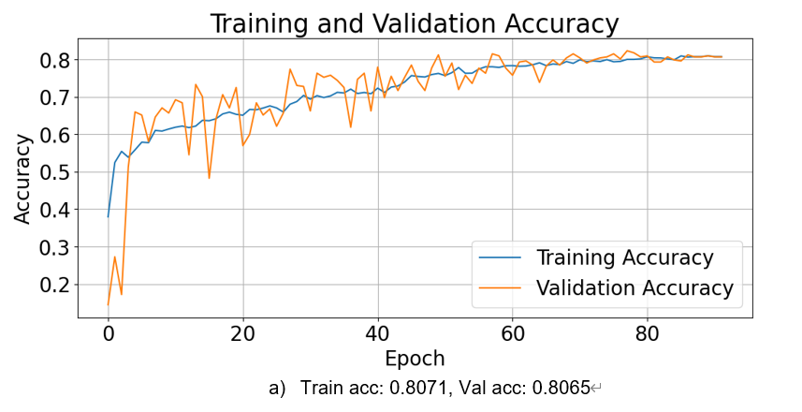

Figure 20: Training and Validation Accuracy Trends

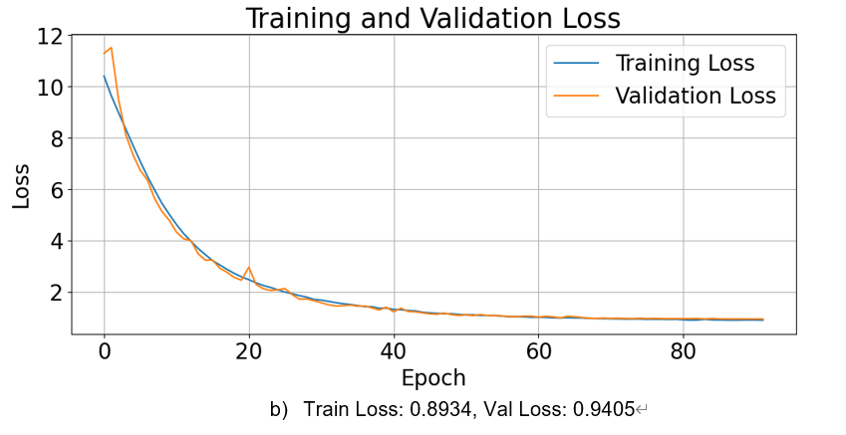

Figure 21: Training and Validation Loss Trends

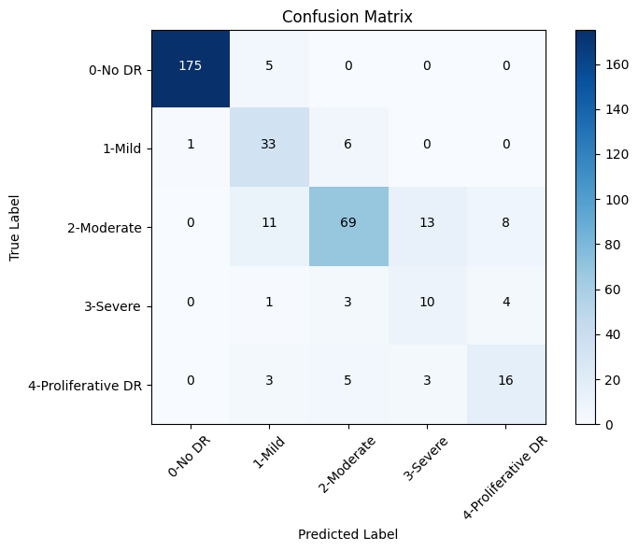

Figure 22: Confusion Matrix for Diabetic Retinopathy Classification

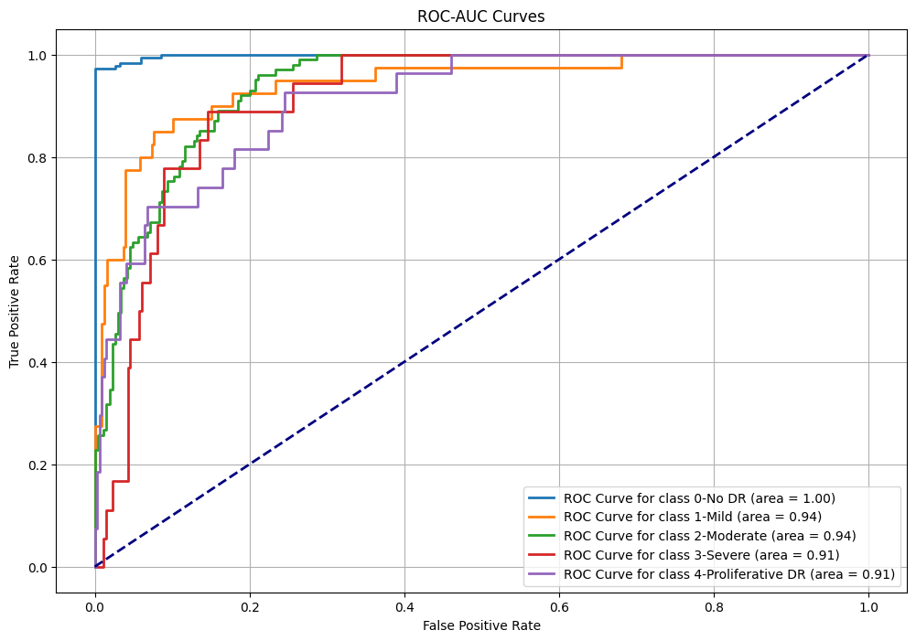

Figure 23: ROC-AUC Performance Evaluation

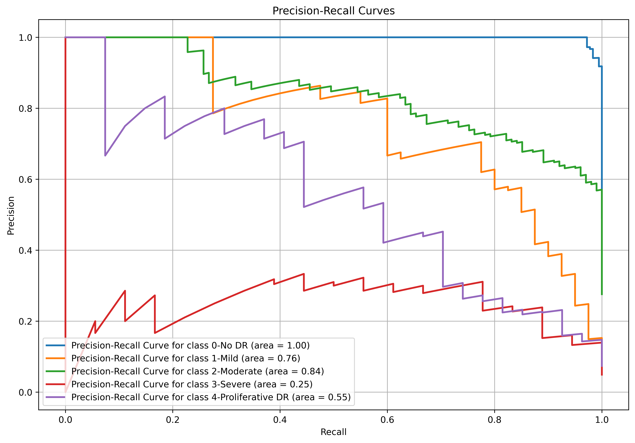

Figure 24: Precision-Recall Curves

|  |  |  |  |  |  |  |  |  |
| --- | --- | --- | --- | --- | --- | --- | --- | --- |
| Authors | Datasets | Acc  (%) | Loss  (%) | AUC  (%) | f1  (%) | Sen (%) | Spec  (%) | Prec  (%) |
|  |  |  | 15 | X | X | 87.9 | 84 | X |
|  |  |  | X |  |  |  |  | X |
|  |  | X |  |  |  |  | X |
|  |  |  | X | X | X | X | X | X |
|  |  |  |  |  |  |  |  |  |
|  |  |  |  |  |  |  |  | X |
|  |  |  | X |  | X | X | X | X |
|  |  |  | X |  | X | X | X | X |
|  |  | X |  | X | X | X | X |
|  |  | X |  | X | X | X | X |
|  |  |  | X |  | X |  |  |  |
|  |  |  | X |  | X | X | X | X |
|  |  |  | X | X |  |  |  |  |
|  |  |  | X | X | X | X | X | X |
|  |  |  |  |  |  |  |  |  |

## Model Visualization (XAI)

Explainable AI (XAI) techniques play a vital role in improving the interpretability of deep learning models, especially in medical imaging, where trust and transparency are crucial for clinical adoption. In this study, we employed three prominent XAI techniques—LIME, Grad-CAM, and SHAP—to provide insights into the model's decision-making process.

As outlined by Barra et al. [26], LIME generates local explanations by perturbing input images to identify the most influential regions for a given prediction. This approach is valuable for understanding which parts of an image the model focuses on when making predictions. Grad-CAM creates heatmaps that highlight the regions of the image most influential in the model’s decision-making, such as areas showing signs of diabetic retinopathy. Finally, SHAP values provide a fair and consistent way to measure each feature's contribution to the model's output, offering a deeper understanding of which image features influence the model’s prediction the most [26].

Figure 25 presents a LIME explanation for a retinal image diagnosed as 4-Proliferative Diabetic Retinopathy. The left panel displays the original image, while the right panel shows the areas that the model focused on in its prediction. In the LIME explanation, red regions represent the areas most influential to the model’s decision, while green regions highlight less critical areas. A significant portion of the disease-related areas, such as lesions and abnormal blood vessels, is marked in green, indicating that the model successfully identifies and considers most of the affected regions. However, the red regions, which likely correspond to neovascularization (new blood vessel formation), are the most important for the model’s prediction, reflecting its ability to prioritize key features associated with Proliferative DR. This demonstrates that the model not only detects a large proportion of the disease areas but also differentiates between critical and less important regions, reinforcing the reliability of its predictions.

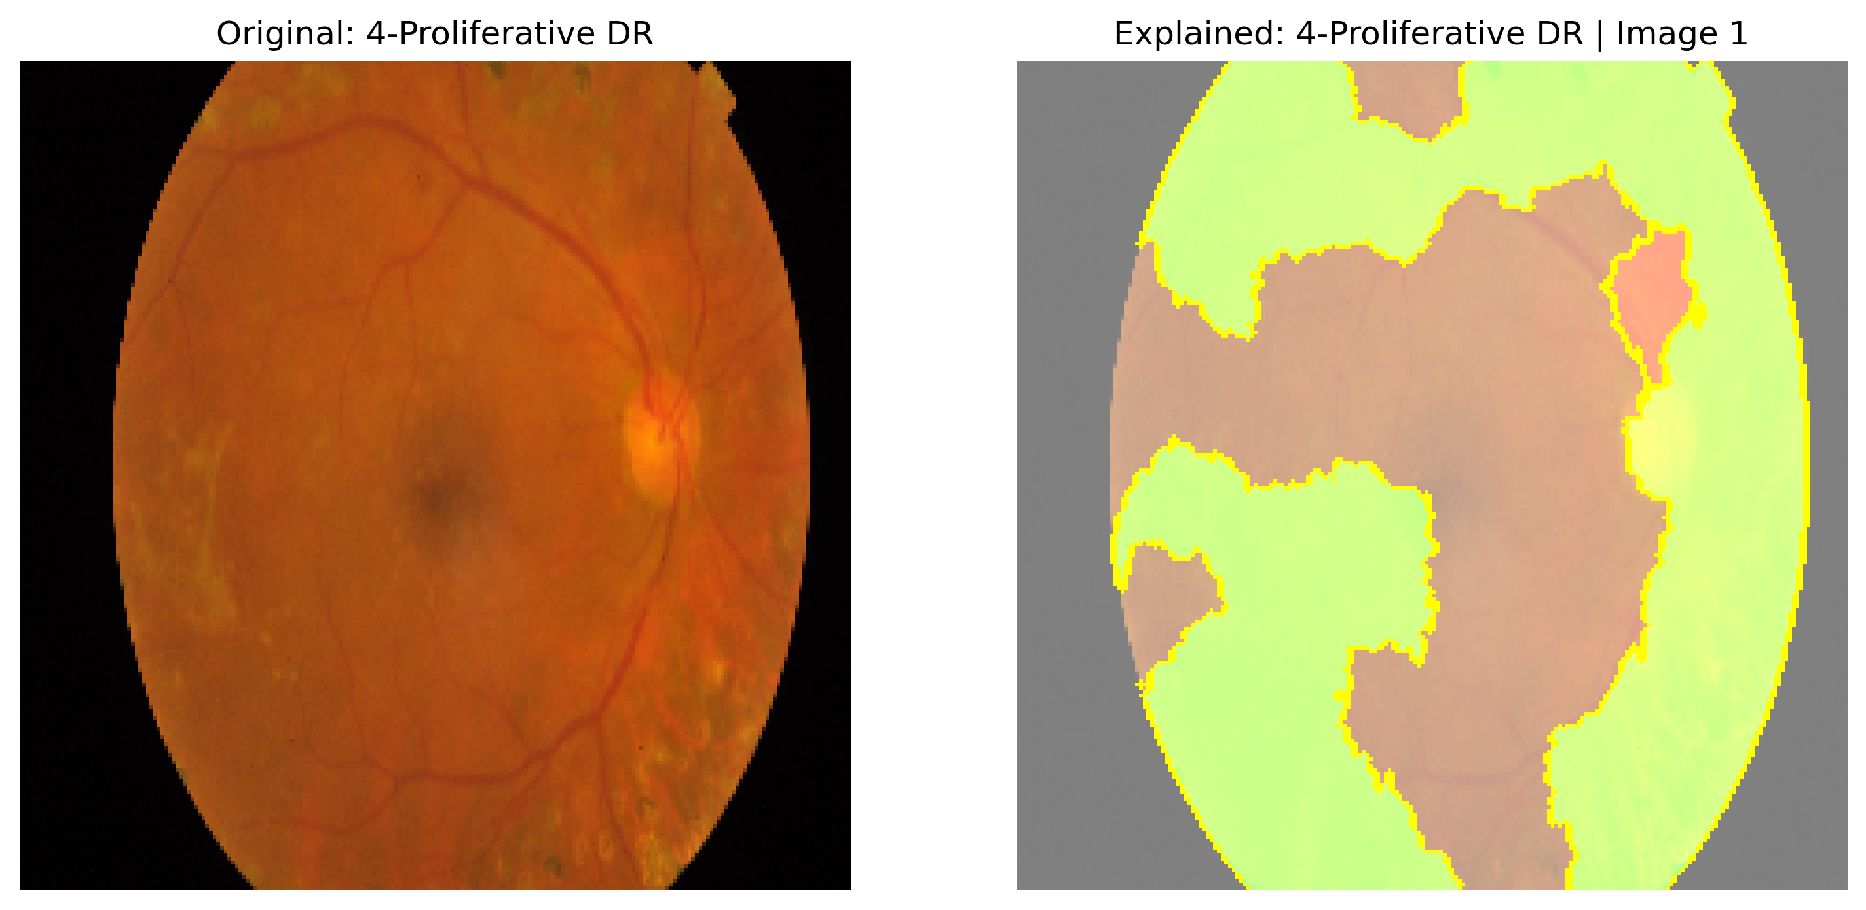

Figure 25: LIME

Figure 26 presents a Grad-CAM explanation for a retinal image diagnosed as 3-Severe Diabetic Retinopathy. The left panel shows the original image, while the right panel illustrates the Grad-CAM enhanced image, where the model’s areas of focus are visualized. The red and yellow regions indicate areas that are most influential in the model’s decision, with exudates and hemorrhages being the key features associated with Severe DR. These areas are prioritized by the model, demonstrating its ability to identify the critical regions of the disease. On the other hand, the blue and green regions represent areas with lower influence but highlight the model’s capacity to accurately distinguish the black borders of the retina. The model’s focus on these boundaries shows its effectiveness in accurately segmenting and differentiating between disease-related features and non-relevant areas. This suggests that the model not only recognizes the most significant pathological features but also demonstrates a high level of reliability in its predictions for Severe DR, effectively distinguishing both the key signs of the disease and the image's boundaries.

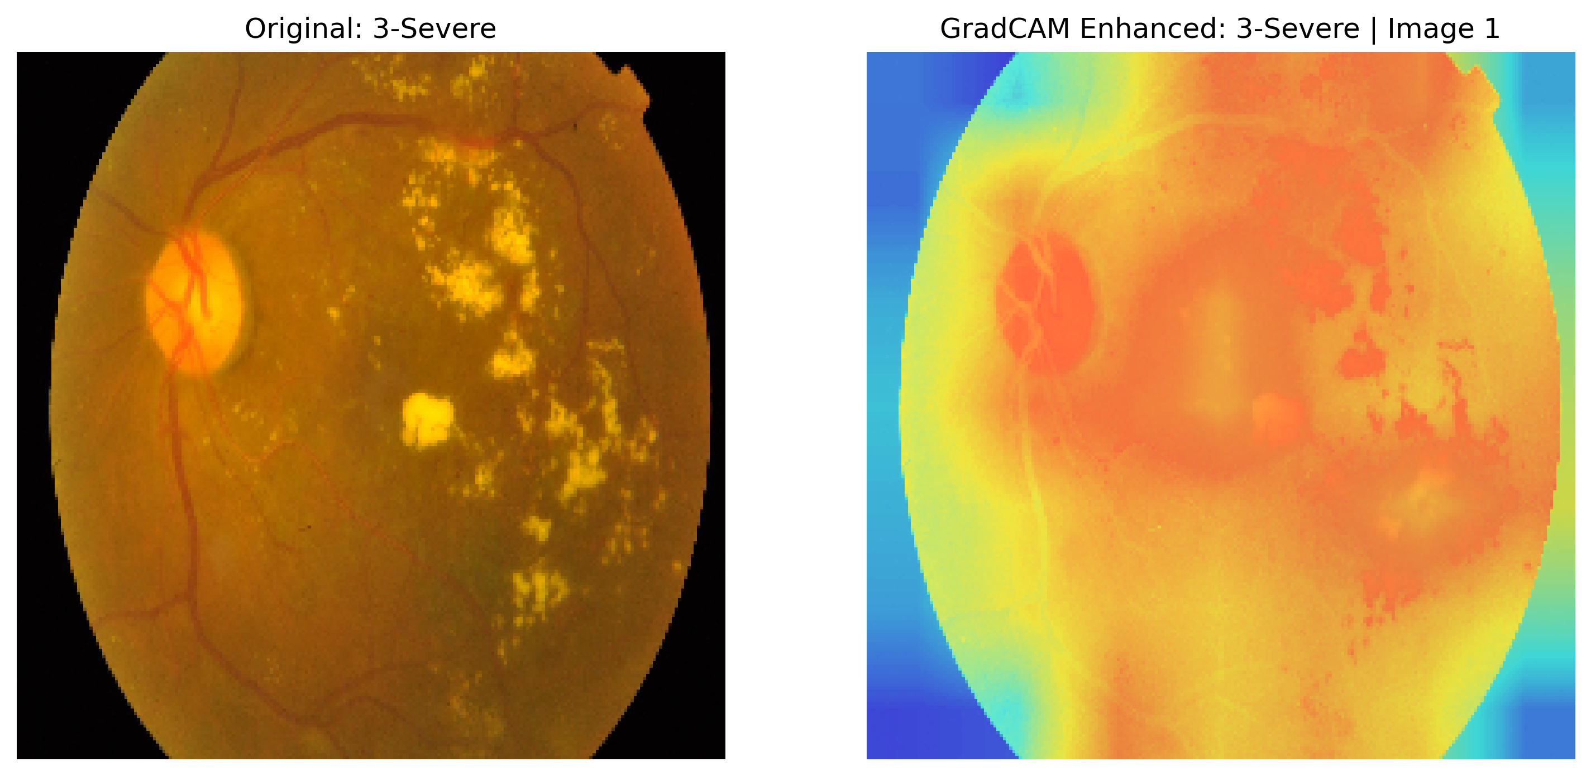

Figure 26: Grad-CAM

Figure 27 presents a SHAP-based explanation of a retinal image diagnosed with Moderate Diabetic Retinopathy. The left panel shows the original image, while the right panel displays the SHAP-enhanced version, where each pixel's contribution to the model's prediction is shown with a color map—red indicates a positive contribution, and blue represents a negative one. The red regions surrounding areas that are difficult to detect with the naked eye suggest that the model has successfully identified these subtle signs of Moderate DR. Notably, the centers of these red regions are mainly blue, indicating that the model is focused on the broader affected areas rather than the smaller, finer details within them. This suggests the model concentrates on the overall extent of the disease, such as the general retinal damage, rather than being influenced by minor features like isolated lesions. This approach highlights the model’s ability to identify all affected areas, even those that are hard to spot visually, and prioritize larger disease patterns, making it more reliable and robust for diagnosing Moderate DR in clinical settings.

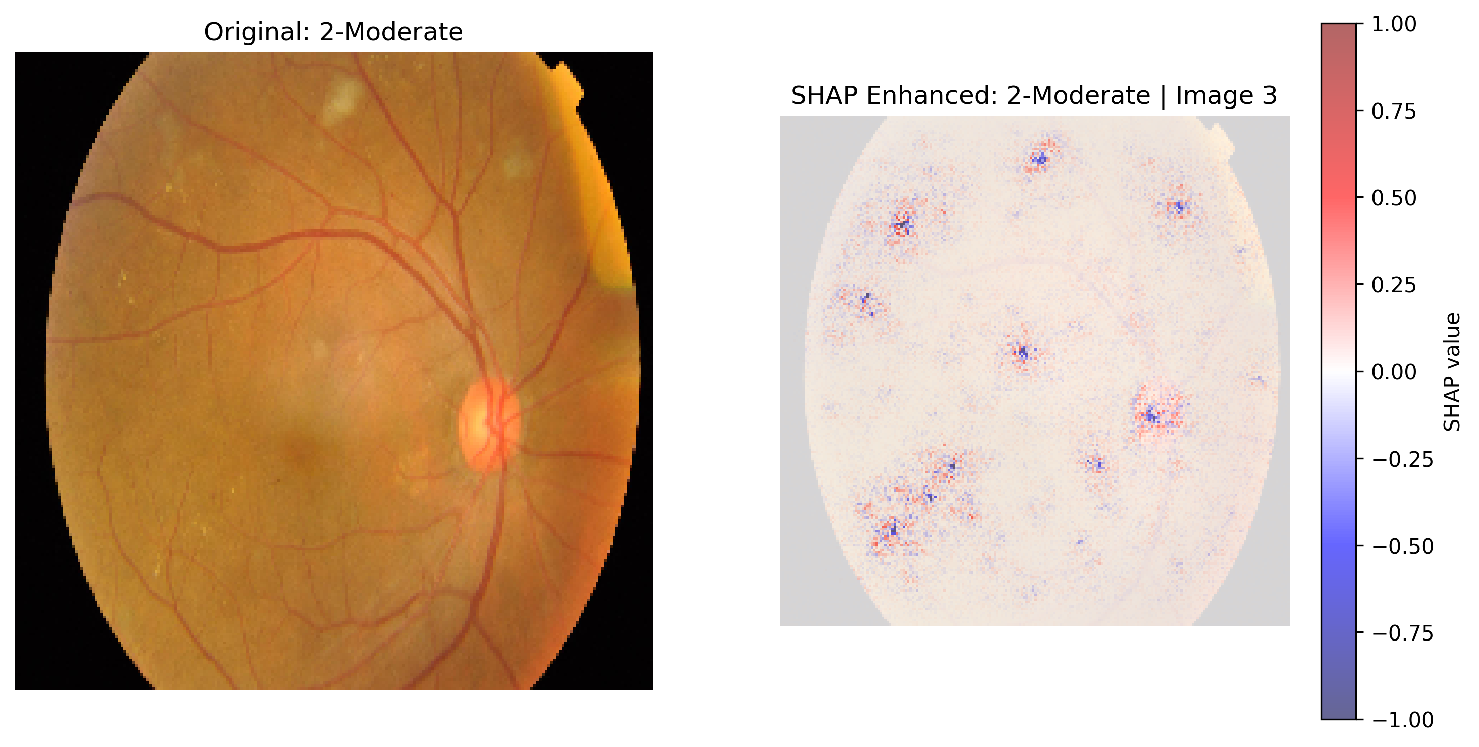

Figure 27: SHAP

## Model Deployment

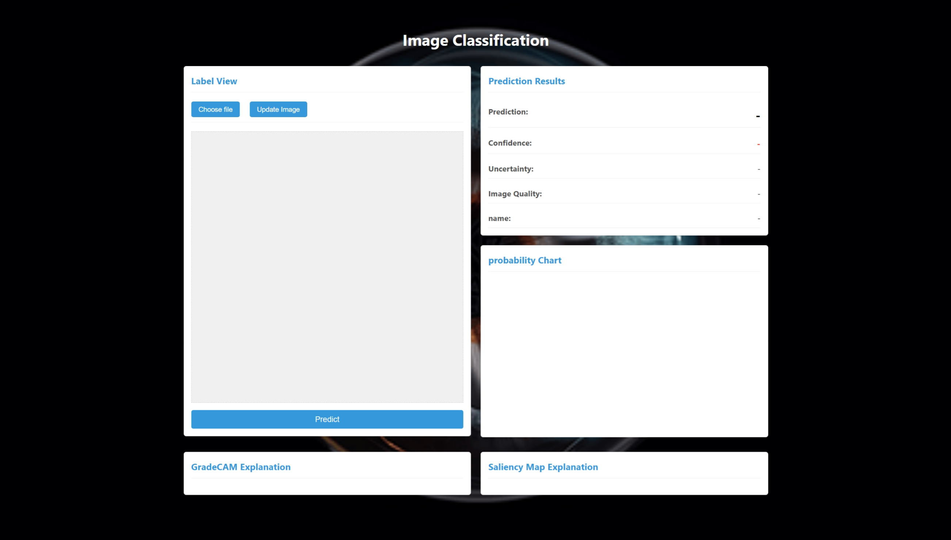

Figure 28: Main Page

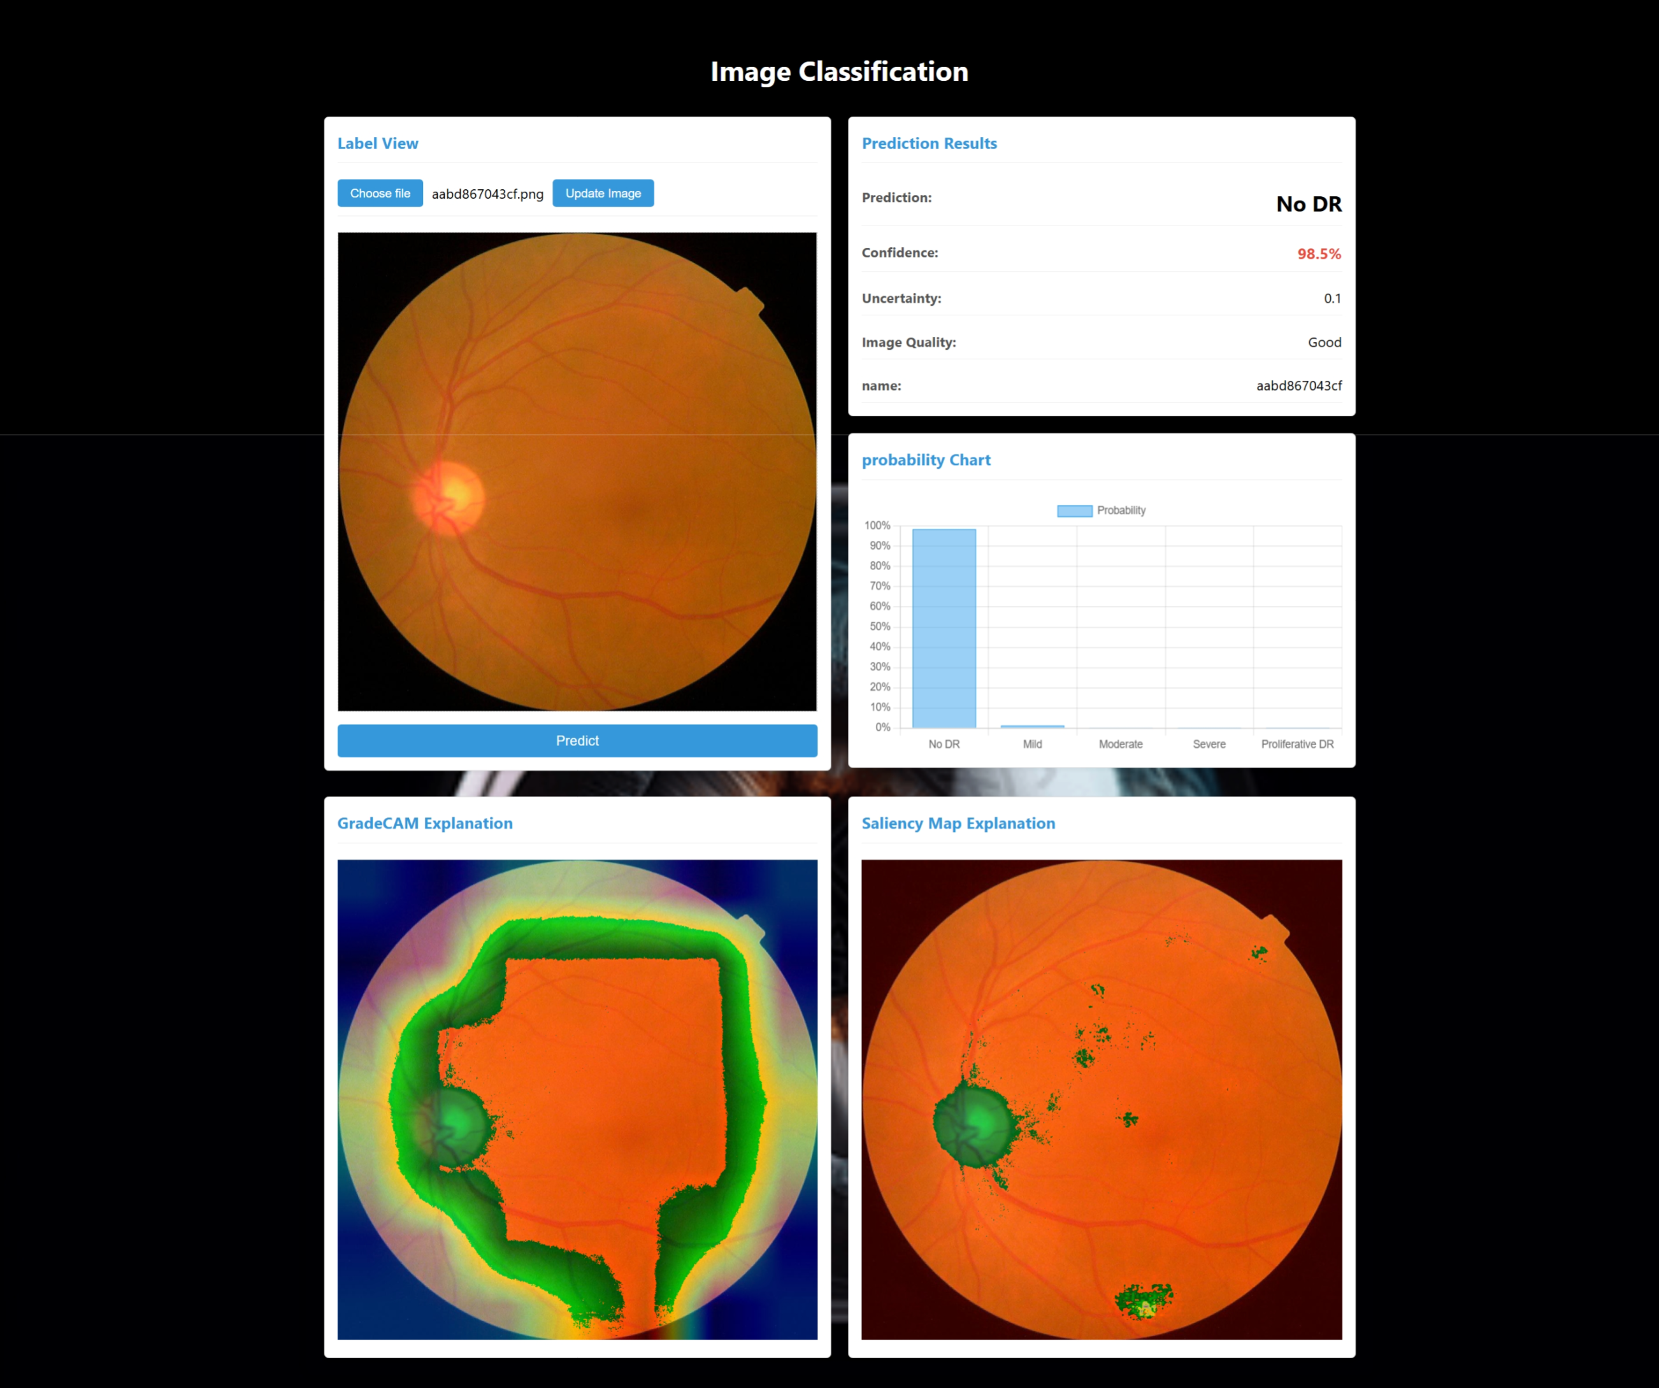

Figure 29: Prediction of No DR

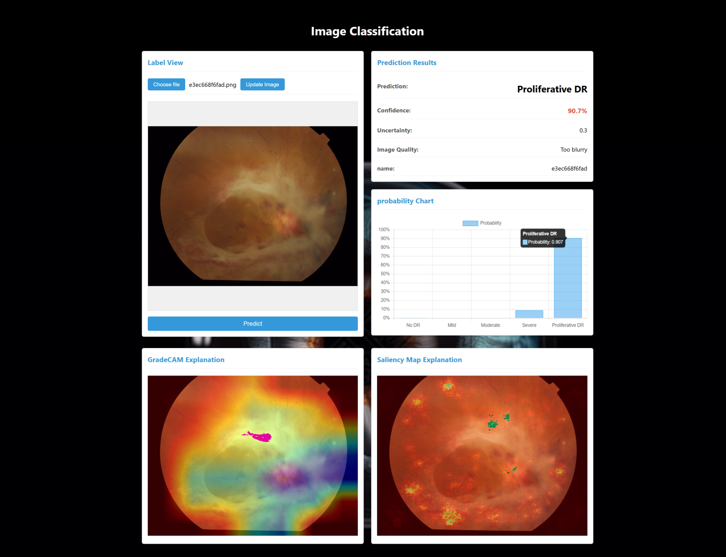

Figure 30: Prediction of Proliferative DR

# **Professional Issues**

## **Project Management**

### **Activities**

The activities are shown as table 2 below.

|  |  |
| --- | --- |
| Objectives | Activities |
| **Data Collection and Preparation**  **(Completed)** | Collect the APTOS 2019 Blindness Detection dataset |
| Preprocess the image, including resizing and normalization |
| Perform data augmentation to increase the diversity of training data |
| Split the dataset into training, validation, and test sets |
| **Model Development**  **(Completed)** | Design a deep learning model based on the ResNet architecture |
| Implement a custom loss function to handle class imbalance |
| Adjust the network architecture as needed to optimize feature extraction |
| Write and test code for model architecture setup |
| **Training and Optimization**  **(Completed)** | Set initial hyperparameters and conduct training |
| Monitor training progress and make necessary adjustments |
| Optimize code, improve technology, improve accuracy and reduce loss value. |
| **Model Evaluation and ending**  **(****Completed)** | Use XAI such as Grad-CAM to judge model reliability |
| Evaluate the model using a separate test set with metrics such as accuracy, precision, recall, F1-score, and AUC |
| Fine-tune and improve the model based on evaluation results |
| Compare with other models |
| Summarize the work, write the final report and prepare the presentation |

Table 8: Project Workflow

### **Schedule**

The schedule is shown as table 3 below.

The completed parts are marked in blue and the uncompleted parts are marked in orange.

Table 9: Gantt Chart

### **Project Data Management**

1. Back up all documents of the project, including data sets, model codes, references, weekly reports, etc. The specific operation is: the code is uploaded to GitHub, and other files are stored in Baidu cloud disk and USB flash drive.

Github URL is as follow:

<https://github.com/buaikeguazi/my-project>

B.Every time the model code or report is modified, upload the code to GitHub, and synchronize other files with the cloud disk locally to ensure that the file versions of all platforms are consistent.

The following is a list of uploading and synchronizing project files:

1. Report documents (weekly report, project proposal, progress report, final report and presentation PPT).
2. CNN model structure diagram
3. references
4. Dataset link
5. Model evaluation file
6. CNN model code

### **Project Deliverables**

A. The project proposal

B. Weekly report

C. Progress Report

D. Final Project Report

E. Project codes

F. Project presentation slides

G. Project presentation

## **Risk Analysis**

Table 4 displays the analyzed risks during the project progress.

|  |  |  |  |  |  |  |  |  |
| --- | --- | --- | --- | --- | --- | --- | --- | --- |
| **Risk ID** | **Potential Risk** | **Cause ID** | **Potential Causes** | **Severity** | **Likelihood** | **Risk** | **Mitigation ID** | **Mitigation** |
| R1.1 | Missed deadline | C1.1.1 | Illness | 1 | 2 | 2 | M1.1.1 | Register exceptional circumstances if ill. |
| C1.1.2 | Poor time management | 4 | 3 | 12 | M1.1.2 | Develop a detailed Gantt chart and adhere to weekly milestones. |
| R1.2 | Feature creep | C.1.2.1 | Over-ambitious project spec. | 3 | 2 | 6 | M1.2.1 | Prioritize features into must-have and nice-to-have, and consult supervisor. |
| R1.3 | Software bugs | C1.3.1 | Non-modular design | 2 | 2 | 4 | M1.3.1 | Create highly modular desigh before implementation |
| C1.3.2 | Poor test plan | 4 | 3 | 12 | M1.3.2 | Create test plan at start |
| R1.4 | Loss of data | C1.4.1 | Poor version control | 4 | 4 | 16 | M1.4.1 | Use a version control system (e.g., Git) from the start and maintain backups. |
| R1.5 | Poor model performance | C1.3.1 | Class imbalance affecting model accuracy | 4 | 3 | 12 | M1.5.1 | Apply data augmentation, class weights, and custom loss function. |
| C1.3.2 | Overfitting on training data | 3 | 2 | 6 | M1.5.2 | Regularly validate model on validation set and adjust hyperparameters. |

Table 10: Risk Analysis

## **Professional Issues**

In this project, multiple legal, social, ethical, and environmental issues are intertwined throughout its development, implementation, and application, demanding full attention at each stage.

**Legal Issues**: For this project, data privacy and protection are crucial when using the APTOS 2019 dataset. Ensure patients' explicit consent for non-commercial research and comply with data protection regulations like GDPR to prevent leaks. Also, any used open-source frameworks (e.g., TensorFlow) and the ResNet model must adhere to license agreements.

**Social Issues**: The project aims to assist doctors in classifying diabetic retinopathy via deep learning. It must ensure fairness and acceptability, providing consistent results for all patient groups and avoiding biases. Model results should be transparent and interpretable as it's an auxiliary tool, not a replacement for doctors.

**Ethical Issues**: Ethics are vital. Minimize biases in model design and training, especially with class imbalance, to accurately classify severe cases. Ensure ethical data collection and clarify error responsibility. Record and analyze the decision-making path for potential misjudgments.

**Environmental Issues:** In terms of environmental impact, the training of deep - learning models (such as ResNet) requires a large amount of computing resources, which may lead to high energy consumption. Therefore, in the project, every effort should be made to optimize the model architecture, reduce computational complexity, and thus lower energy consumption.

According to BCS and ACM codes, the project centers on the public interest, aiming to enhance early diagnosis for patients and institutions. The team must maintain professionalism and integrity, avoid algorithmic biases, and provide objective model descriptions.

By paying attention to the above legal, social, ethical, and environmental issues, this project can not only ensure compliance with relevant legal and ethical standards in technological development but also provide a reliable, fair, and socially valuable technical solution for the medical industry. This comprehensive consideration will contribute to the application, promotion, and long - term sustainable development of the project results.

# **Conclusion**

This project proposes a deep learning model based on the ResNet architecture, designed to address the classification task of diabetic retinopathy (DR), especially when dealing with class imbalance in medical datasets. By utilizing a custom model architecture and the BalancedSoftmaxLoss loss function, this model demonstrates stronger classification performance and better generalization compared to traditional methods.

The model was validated on the APTOS 2019 Blindness Detection (public) dataset and compared with several pre-trained models (such as EfficientNetV2, InceptionV3, ResNet50, etc.). In both the 5-class and 4-class tasks, the model exhibited excellent accuracy and F1 scores. In the 5-class task, the model achieved good performance with a micro-average accuracy of 0.83 and a macro-average accuracy of 0.73. In the 4-class task, due to the similarity between the Severe DR and Proliferative DR categories, making them difficult to distinguish, these two categories were merged, resulting in an increase in the micro-average accuracy to 0.87 and a macro-average accuracy of 0.84. This demonstrates the model's effectiveness in handling class imbalance. In particular, the model improved recall for the minority classes in the merged categories through the custom loss function, enhancing its performance in dealing with complex cases.

A key innovation of this model is the use of the custom BalancedSoftmaxLoss loss function, which addresses class imbalance by mitigating the bias towards the majority class that is common in traditional Softmax activation functions. With this loss function, the model shows no significant shortcomings in classifying minority categories (such as Mild, Severe DR, and Proliferative DR), effectively balancing recall and F1 scores across all classes, and further improving diagnostic accuracy.

Additionally, the integration of Explainable AI (XAI) technology has enhanced the model's interpretability, making its decision-making process more transparent. This is particularly valuable in medical contexts, as it allows healthcare professionals to understand and trust the model's predictions.

Despite the model achieving good accuracy and performance, current hardware limitations and training time constraints remain bottlenecks for further optimization. Compared to state-of-the-art research, this model still has room for improvement. Future efforts could focus on hardware acceleration, optimizing training strategies, and further model lightweighting to improve efficiency and scalability.

Future research directions should focus on the following areas: first, optimizing the model's lightweight design to reduce training time and computational costs; second, expanding validation on other public datasets to improve the model's generalization ability; third, exploring more innovative methods to address class imbalance, thereby enhancing the model's diagnostic capabilities and clinical applicability; and fourth, attempting to integrate the use of pre-trained models and leverage pre-trained weights to further improve the model's performance and efficiency.

In conclusion, although this model still has room for improvement, it demonstrates significant potential for early diagnosis of diabetic retinopathy, clinical decision support, and practical applications. Its value is particularly notable in resource-limited medical environments, where it offers great potential for widespread implementation.

# **References**

[1] H. Omer, ‘Diabetic Retinopathy Detection Using Bilayered Neural Network Classification Model with Resubstitution Validation’, *MethodsX*, vol. 12, p. 102705, Apr. 2024, doi: 10.1016/j.mex.2024.102705.

[2] K. Liu, T. Si, C. Huang, Y. Wang, H. Feng, and J. Si, ‘Diagnosis and detection of diabetic retinopathy based on transfer learning’, *Multimed. Tools Appl.*, vol. 83, no. 35, pp. 82945–82961, Oct. 2024, doi: 10.1007/s11042-024-18792-x.

[3] V. Thanikachalam, K. Kabilan, and S. K. Erramchetty, ‘Optimized deep CNN for detection and classification of diabetic retinopathy and diabetic macular edema’, *BMC Med. Imaging*, vol. 24, no. 1, Art. no. 1, Dec. 2024, doi: 10.1186/s12880-024-01406-1.

[4] Q. Xiao *et al.*, ‘A computer vision and residual neural network (ResNet) combined method for automated and accurate yeast replicative aging analysis of high-throughput microfluidic single-cell images’, *Biosens. Bioelectron.*, vol. 244, p. 115807, Jan. 2024, doi: 10.1016/j.bios.2023.115807.

[5] U. Bhimavarapu, N. Chintalapudi, and G. Battineni, ‘Automatic Detection and Classification of Diabetic Retinopathy Using the Improved Pooling Function in the Convolution Neural Network’, *Diagnostics*, vol. 13, no. 15, Art. no. 15, Jan. 2023, doi: 10.3390/diagnostics13152606.

[6] Y. Suo, Z. He, and Y. Liu, ‘Deep learning CS-ResNet-101 model for diabetic retinopathy classification’, *Biomed. Signal Process. Control*, vol. 97, p. 106661, Nov. 2024, doi: 10.1016/j.bspc.2024.106661.

[7] C.-L. Lin and K.-C. Wu, ‘Development of revised ResNet-50 for diabetic retinopathy detection’, *BMC Bioinformatics*, vol. 24, no. 1, p. 157, Apr. 2023, doi: 10.1186/s12859-023-05293-1.

[8] F. Kallel and A. Echtioui, ‘Retinal fundus image classification for diabetic retinopathy using transfer learning technique’, *Signal Image Video Process.*, vol. 18, no. 2, pp. 1143–1153, Mar. 2024, doi: 10.1007/s11760-023-02820-8.

[9] T. Karkera, C. Adak, S. Chattopadhyay, and M. Saqib, ‘Detecting severity of Diabetic Retinopathy from fundus images: A transformer network-based review’, *Neurocomputing*, vol. 597, p. 127991, Sep. 2024, doi: 10.1016/j.neucom.2024.127991.

[10] M. Arunika, S. Saranya, S. Charulekha, S. Kabilarajan, and G. Kesavan, ‘A Survey on Explainable AI Using Machine Learning Algorithms Shap and Lime’, in *2024 15th International Conference on Computing Communication and Networking Technologies (ICCCNT)*, Jun. 2024, pp. 1–6. doi: 10.1109/ICCCNT61001.2024.10725120.

[11] F. Cotter and N. Kingsbury, ‘Deep Learning in the Wavelet Domain’, Nov. 14, 2018, *arXiv*: arXiv:1811.06115. doi: 10.48550/arXiv.1811.06115.

[12] J. Liu, F. Guo, H. Gao, Z. Huang, Y. Zhang, and H. Zhou, ‘Image classification method on class imbalance datasets using multi-scale CNN and two-stage transfer learning’, *Neural Comput. Appl.*, vol. 33, no. 21, pp. 14179–14197, Nov. 2021, doi: 10.1007/s00521-021-06066-8.

[13] S. Sakib, Ahmed, A. Jawad, J. Kabir, and H. Ahmed, *An Overview of Convolutional Neural Network: Its Architecture and Applications*. 2018. doi: 10.20944/preprints201811.0546.v1.

[14] C. Yu, P.-H. Hung, J.-H. Hong, and H.-Y. Chiang, ‘Efficient Max Pooling Architecture with Zero-Padding for Convolutional Neural Networks’, in *2023 IEEE 12th Global Conference on Consumer Electronics (GCCE)*, Oct. 2023, pp. 747–748. doi: 10.1109/GCCE59613.2023.10315268.

[15] W. Xu, Y.-L. Fu, and D. Zhu, ‘ResNet and its application to medical image processing: Research progress and challenges’, *Comput. Methods Programs Biomed.*, vol. 240, p. 107660, Oct. 2023, doi: 10.1016/j.cmpb.2023.107660.

[16] S. Kaman and A. Makandar, ‘Optimizing Pretrained Model with Squeeze-and-Excitation Blocks for Improved Image Forgery Detection’, in *2024 International Conference on Innovation and Novelty in Engineering and Technology (INNOVA)*, Dec. 2024, pp. 1–6. doi: 10.1109/INNOVA63080.2024.10847047.

[17] Z. Ba, L. Wu, J. Hu, L. Wu, and X. Zhang, ‘Multi-Head Attention Hardware Implementation and Side-Channel Security Analysis for Transformer’, in *2024 9th International Conference on Integrated Circuits and Microsystems (ICICM)*, Oct. 2024, pp. 842–846. doi: 10.1109/ICICM63644.2024.10814141.

[18] T.-C. Pham, A. Doucet, C.-M. Luong, C.-T. Tran, and V.-D. Hoang, ‘Improving Skin-Disease Classification Based on Customized Loss Function Combined With Balanced Mini-Batch Logic and Real-Time Image Augmentation’, *IEEE Access*, vol. 8, pp. 150725–150737, 2020, doi: 10.1109/ACCESS.2020.3016653.

[19] B. Kang *et al.*, ‘Decoupling Representation and Classifier for Long-Tailed Recognition’, Feb. 19, 2020, *arXiv*: arXiv:1910.09217. doi: 10.48550/arXiv.1910.09217.

[20] R. Romero-Oraá, M. Herrero-Tudela, M. I. López, R. Hornero, and M. García, ‘Attention-based deep learning framework for automatic fundus image processing to aid in diabetic retinopathy grading’, *Comput Methods Prog Biomed*, vol. 249, no. C, Jul. 2024, doi: 10.1016/j.cmpb.2024.108160.

[21] Y. Yang, Z. Cai, S. Qiu, and P. Xu, ‘A Novel Transformer Model With Multiple Instance Learning for Diabetic Retinopathy Classification’, *IEEE Access*, vol. 12, pp. 6768–6776, 2024, doi: 10.1109/ACCESS.2024.3351473.

[22] R. Al-ahmadi, H. Al-ghamdi, and L. Hsairi, ‘Classification of Diabetic Retinopathy by Deep Learning’, *Int. J. Online Biomed. Eng. IJOE*, vol. 20, no. 01, Art. no. 01, Jan. 2024, doi: 10.3991/ijoe.v20i01.45247.

[23] K. Ahnaf Alavee *et al.*, ‘Enhancing Early Detection of Diabetic Retinopathy Through the Integration of Deep Learning Models and Explainable Artificial Intelligence’, *IEEE Access*, vol. 12, pp. 73950–73969, 2024, doi: 10.1109/ACCESS.2024.3405570.

[24] R. Baskar, E. Sabu, and C. Mazo, ‘Deep CNNs for Diabetic Retinopathy Classification: A Transfer Learning Perspective’, in *2024 IEEE International Symposium on Biomedical Imaging (ISBI)*, May 2024, pp. 1–4. doi: 10.1109/ISBI56570.2024.10635242.

[25] K. G. Kumar, S. Aparna, P. Bhavadharani, E. B. Logesh, and M. D. Sri Raam, ‘Diabetic Retinopathy Severity Detection Using InceptionV3 and ResNet50 Architectures’, in *2024 13th International Conference on System Modeling & Advancement in Research Trends (SMART)*, Dec. 2024, pp. 92–96. doi: 10.1109/SMART63812.2024.10882494.

[26] P. Barra, A. Della Greca, I. Amaro, A. Tortora, and M. Staffa, ‘A Comparative Analysis of XAI Techniques for Medical Imaging: Challenges and Opportunities’, in *2024 IEEE International Conference on Bioinformatics and Biomedicine (BIBM)*, Dec. 2024, pp. 6782–6788. doi: 10.1109/BIBM62325.2024.10821983.

# **Appendices**

The project is on Github, URL is as follow:

<https://github.com/buaikeguazi/my-project>

Dataset link:

https://www.kaggle.com/c/aptos2019-blindness-detection/data?select=train_images